The Authority of Sharing: postgraduate blogging in Classics

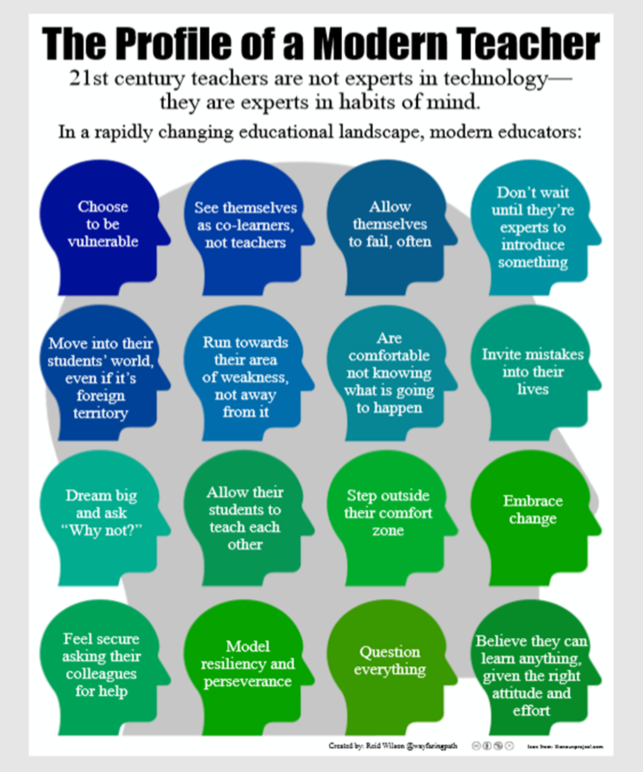

From Reid Wilson at https://wayfaringpath.coetail.com/2014/10/14/the-profile-of-a-modern-teacher/
https://creativecommons.org/licenses/by-nc-nd/3.0/

Selected References

Academic blogs
A survey of 100 unofficial academic blogs: ‘The most common audience was academic (73%) followed by professional (38%), and the least common was researchers (6%), followed by students (15%). The educated public was marginally more common than students at 17% of blogs. We concluded from this analysis that most academic bloggers were actually writing for themselves – or people like themselves – rather than explicitly trying to reach a group of people differently circumstanced.’
Mewburn, I. and P. Thomson (2013) ‘Why do academics blog? An analysis of audiences, purposes and challenges’, Studies in Higher Education 38.8, p.1113.

Professional control
‘The academic super-hero’, who ‘must be ready to deal with the multiple uncertainties that beset the higher education sector… all the while collecting business cards for that next round of student placements, soothing hurt feelings and smiling graciously at the crowds of prospective students at Open Day while publishing prodigiously and creating innovative learning opportunities for their students across multiple media’
Pitt, R. and I. Mewburn (2016) ‘Academic superheroes? A critical analysis of academic job descriptions’, Journal of Higher Education Policy and Management, p.99.

Postgraduate identity
A recent investigation highlighted particular groups of postgraduates at risk for mental health problems due to identity issues: ‘Some learners were uncertain as to how they fitted in and were acutely aware of holding a relatively low status – feelings which were particularly profound in the cases of working-class, mature women, carers, students with disabilities and International students’.
Morris, C. (2018) ‘Supporting postgraduate student wellbeing and belonging’, (In)Equitable Academy? A Blog by the Centre for Higher Education and Equity Research, online at https://equityhe.wordpress.com/2018/08/29/supporting-postgraduate-student-wellbeing-and-belonging/.

Blogging and identity
‘…the identities created through traditional kinds of scholarly writing styles embody values and worldviews that run counter to both the identities that students bring to higher education as well as the identities that a more diverse “workforce” of scholars, researchers and teachers now embodies’. Blogs offer the hope that people who find their identity to be in conflict with traditional forms of writing ‘will find that blogging offers them a form of writing which enables them to perform new, and less conflicted, kinds of academic identity’.
Kirkup, G. (2010) ‘Academic blogging: academic practice and academic identity’, London Review of Education 8.1, 75-84.

